Going beyond ACI 332: Commercial / Residential Enhanced Durability Concrete: First Look

L. K. Crouch, Samuel Mathews, Daniel Badoe, and Alan Sparkman

Introduction

The use of commercially-available deicing salts containing magnesium chloride (MgCl) on residential and commercial concrete such as sidewalks, driveways, etc. can lead to premature deterioration of the concrete. The Tennessee Concrete Association (TCA) approached Tennessee Technological University (TTU) researchers for additional ideas, beyond those in American Concrete Institute Residential Code Requirements for Structural Concrete (ACI 332-14) and Commentary. TTU researchers postulated that the rate and amount of damage to commercial and residential concrete would be controlled by the chloride permeability and absorption of the concrete. TTU researchers began a pilot study to determine if lower chloride permeability and absorption mixtures could be developed that met (or nearly met) Code Requirements for Residential Concrete (ACI 332-08) requirements. The TTU pilot study will be discussed shortly but let us look at some pertinent literature.

Literature Review

According to the Federal Highway Administration (FHWA), over 70% of the nation’s roads are located in areas that receive on average five inches of snowfall per year in addition to almost 70% of the U.S. population inhabiting these areas (1). While this refers to asphalt and concrete pavements, roadways are not the only thing effected by winter weather. Since these areas that are prone to winter weather are densely populated, steps must be taken in order to maintain the navigability of roadways, sidewalks, parking lots, driveways, etc. In order to do this, deicing solutions such as MgCl and sodium chloride (NaCl) are applied to deter snowfall or ice from building up on concrete surfaces (2). Unfortunately, deicing solutions can negatively affect concrete (3).

Damage caused by NaCl can be seen physically, whereas damage caused by MgCl cannot be seen by inspecting visually which is the common method for assessing the condition of a bridge (4). When a concrete is exposed to low concentrations of NaCl, there is very little impact on the properties of the concrete. At higher concentrations, there is a greater impact but this impact is still small (5). The majority of physical damage caused by the exposure to deicing solutions is in the form of scaling which does not debilitate the concrete by itself. However, scaling invites more deicing solutions or other chemicals that may be present to enter into the concrete matrix (3). When a concrete is subject to low concentrations of MgCl, considerable damage can occur to the concrete. At high concentrations, there is significant damage that occurs including the loss of material, strength, and stiffness (5).

In order to extend the service life of concrete that is exposed to winter weather and deicing solutions, one of the most effective methods is to incorporate the use of a low permeability concrete (6). According to the American Concrete Institute (ACI), “Permeability is a measure of the amount of water, air, and other substances that can enter the concrete matrix” (7). There are several strategies that can be used in order to reduce the permeability of concrete. Some of these strategies are as follows: incorporating the use of a supplementary cementitious material (SCM), lowering the water-to-cement ratio, employing the use of superplasticizers, proper placement, proper finishing, and adequate curing (8, 9, 10, 11).

SCM’s like Class C and Class F fly ash increase the ability for concrete to withstand freeze-thaw damage and even effects of other chemicals that enter the concrete matrix such as acids, salts, or sulfates (12). Other SCM’s like ground granulated blast-furnace slag (GGBFS) also are used to reduce permeability of concrete. Although, the use of GGBFS decreases the permeability of the concrete matrix, the FHWA reports that, “concrete containing high concentrations of GGBFS may be susceptible to salt scaling” (13). If the application of the concrete will be exposed to deicing salts, tests should be performed prior to placement in order to find any potential durability issues due to the use of high substitution of GGBFS (13).

TTU Pilot Study
TTU researchers discussed the MgCl problem with the TCA Executive Director in 2018 and attempted to develop commercial and residential enhanced durability (CRED) mixtures with the properties shown in Table 1. The CRED mixtures were intended to meet ACI 332-08 Type 3 Severe requirements for minimum compressive strength. However, the CRED mixtures were to be focused on limiting chloride permeability and absorption after boiling in an attempt to reduce both the rate and amount of MgCl entering the concrete.

Table 1: Proposed Commercial & Residential Enhanced Durability (CRED) Concrete

 | CRED Level 1 | CRED Level 2 | CRED Level 3
14-day Mean SR (kΏ-cm) |  |  | V Low (SR ≥37)
28-day Mean SR (kΏ-cm) | Low (SR ≥21) | V Low (SR ≥37)
28-day Mean Absorption (%) | HPC Level (≤5%) | HPC Level (≤5%) | HPC Level (≤5%)
28-day Mean Strength (psi) | ≥ 4500-psi | ≥ 4500-psi | ≥ 4500-psi
w/cm | ≤ 0.45 | ≤ 0.45 | ≤ 0.45
Total cementing material (pcy) | 520 | 520 | 520

Table 2 shows a comparison of an ACI 332 concrete mixture commercially available in middle Tennessee and the three CRED mixtures developed in the TTU pilot study. The three CRED mixtures achieved their respective surface resistivity and absorption after boiling goals. Similarly, the three CRED mixtures easily met compressive strength goals. Additional compressive strength was not desired but the much higher strength values attained were a consequence of enhanced durability. The superiority of the engineering properties of CRED mixtures is evident, but does it result in enhanced MgCl durability?

Table 2: Comparison of Results in the Pilot Study

Mixture | ACI 332 | CRED Level 1 | CRED Level 2 | CRED Level 3
Total Cementing Material (pcy) | 564 | 520 | 520 | 520
Percent Portland Cement | 80 | 60 | 50 | 50
Percent and Type of primary supplementary cementing material | 20 Class C fly ash | 36 Class F fly ash | 50 Slag Grade 100 | 46 Slag Grade 100
Percent and Type of secondary supplementary cementing material | 0 | 4 metakaolin | 0 | 4 metakaolin
w/cm | 0.443 | 0.39 | 0.39 | 0.39
Mean SR Category 7-days | High | Moderate | Moderate | Moderate
Mean SR Category 14-days | High | Low | Low | Very Low
Mean SR Category 21-days | High | Low | Very Low | Very Low
Mean SR Category 28-days | Moderate | Low | Very Low | Very Low
Mean Strength (psi) 14-days | 5067 | 6457 | 7347 | 8300
Mean Strength (psi) 28-days | 5597 | 7097 | 8767 | 9130
Mean Percent Absorption 28-days | 4.96 | 4.48 | 3.15 | 2.75

TCA Study
Concrete Mixtures
TCA and TTU researchers agreed to include four commercial and two CRED mixtures in the MgCl durability study. The rationale for including each mixture in the study is shown in Table 3. Designs for each mixture are shown in Table 4. Table 5 shows a comparison of three mixtures with ACI 332-14 RF3 requirements. ACI 332-14 Commentary indicates that the RF3 Exposure Class should be used for concrete elements such as driveways, curbs, stairs, steps, and porches exposed not only to freezing and thawing in a near saturated state but also exposed to deicing chemicals. CRED Level 1 did not meet ACI 332-14 requirements for substitution of supplementary cementing materials. CRED Level 2 did meet ACI 332-14 requirements for substitution of supplementary cementing materials. The 3500-psi and 4000-psi mixtures were included since they are commonly used in middle Tennessee and were not expected to meet ACI 332 requirements.
Table 3: TCA Study Durability Evaluation Mixture Rationale

Mixture | Cementing materials (pcy) | w/cm | Rationale for Inclusion in the TCA Study
Commercial 3500-psi | 480 | 0.52 | Lower end of commercial spectrum
Commercial 3500-psi with Penetrating Sealer | 480 | 0.52 | Effect of penetrating sealer
Commercial 4000-psi | 500 | 0.49 | Middle of commercial spectrum
Commercial ACI 332 | 564 | 0.44 | Upper end of commercial spectrum
CRED Level 1 | 520 | 0.39 | Effect of Low Chloride Permeability
CRED Level 2 | 520 | 0.39 | Effect of Very Low Chloride Permeability

Table 4: TCA Study Durability Evaluation Mixtures

Materials | Commercial 3500-psi | Commercial 4000-psi | Commercial ACI 332 | CRED Level 1 | CRED Level 2
Type I/II PC, (lbs/CY) | 375 | 398 | 451 | 312 | 260
Grade 100 Slag, (lbs/CY) | 0 | 0 | 0 | 0 | 260
Class F Fly Ash, (lbs/CY) | 0 | 0 | 0 | 187.2 | 0
Class C Fly Ash, (lbs/CY) | 105 | 112 | 113 | 0 | 0
Metakaolin, (lbs/CY) | 0 | 0 | 0 | 20.8 | 0
No. 57 Stone, (SSD lbs/CY) | 1816 | 1860 | 1854 | 1911 | 1927
River Sand, (SSD lbs/CY) | 1279 | 1210 | 1215 | 1250 | 1258
Water (lbs/CY) | 250 | 250 | 250 | 203 | 203
Design Percent Air | 6 | 6 | 5 | 6 | 6
Air Entrainer, (oz/cwt) | 1.05 | 1 | 1.05 | 0.6 | 0.44
Mid-Range Water Reducer (oz/cwt) | 4.18 | 5.37 | 7.42 | 8.75 | 7.32
High-Range Water Reducer, (oz/cwt) | 0 | 0 | 0 | 7.25 | 6.22

Table 5: Comparison of TCA Study Durability Evaluation Mixtures with Requirements

Property | ACI 332 Exposure Class RF3 Requirement | Commercial ACI 332 | CRED Level 1 | CRED Level 2
Cement content (lbs/CY) | None | 564 | 520 | 520
Water-cement ratio | None | 0.44 | 0.39 | 0.39
Percent Class F Fly Ash Substitution (by weight) for PC | 25 maximum | 0 | 36 | 0
Percent Class C Fly Ash Substitution (by weight) for PC | 25 maximum | 20 | 0 | 0
Percent Grade 100 Slag Substitution (by weight) for PC | 50 maximum | 0 | 0 | 50
Total of Fly ash, Silica Fume, Slag and Other Pozzolans Substitution (by weight) for PC* | 35 maximum | 0 | 40 | 0
* - No more than 25% fly ash and no more than 10% silica fume

Conditioning and Testing Procedure

Only one batch of each mixture in the study was used due to limited space in the low temperature (125°F) drying oven. Each batch contained twelve 4-by-8-inch and nine 3-by-6-inch cylinders. Table 6 shows the conditioning protocol for the study. Table 7 shows testing protocol for the TCA study. Compressive strength was determined as per ASTM C 39-18 (14). Split tensile strength was determined as per ASTM C 496-17 (15). Static modulus of elasticity was determined in accordance with ASTM C 469-14 (16). Absorption after boiling was determined as per ASTM C 642-13 (17) at 28-days. For later absorption after boiling test, the MgCl salt had to be removed from the cylinders by alternating cycles of boiling and oven drying prior to determining absorption after boiling. Table 7 also shows the number and type of samples used for each testing procedure.

Table 6: TCA Durability Conditioning for TCA Study Mixtures

Procedure | First 28-days | Odd Weeks 5 -35 | Even Weeks 6 - 36
Limewater curing | X
Drying at 125°F |  | X
Weight Determination |  | X (end of drying)
Digital Image |  | X (end of drying)
Soak in 15% (by weight) solution of commercial deicer containing MgCl |  |  | X (change solution every 4 cycles)

Table 7: Testing Protocol for TCA Study Mixtures

Test or Procedure | 28-days (curing only no conditioning) | 196-days  (after 28-days of curing and 12 cycles of conditioning) | 280-days  (after 28-days of curing and 18 cycles of conditioning)
Compressive strength | 2 4x8 cylinders | 2 4x8 cylinders | 2 4x8 cylinders
Split tensile strength | 2 4x8 cylinders | 2 4x8 cylinders | 2 4x8 cylinders
Static Modulus of Elasticity | 1 4x8 cylinder | 1 4x8 cylinder | 1 4x8 cylinder
Absorption after boiling | 3 3x6 cylinders | 3 3x6 cylinders | 3 3x6 cylinders

Results and Preliminary Analysis

Table 8a and Table 8b shows plastic property results for each mixture and applicable requirements. Table 9 and Figure 1 show mean 3-by-6-inch cylinder weight gain in percent using the mean cylinder weight after the first drying cycle as a control weight. Table 10 and Figure 2 show mean MgCl penetration depth into 4-by-8-inch cylinders from the post-failure cylinders used in 196-day split tension test. Penetration depth seems to qualitatively correlate well with chloride permeability. Surface resistivity (AASHTO T 358-17) was conducted only on 28-day 4-by-8-inch samples since it was not clear to the TTU researchers what effect the MgCl salt residue would have on later chloride permeability results. Tables 11, 12, and 13 show compressive strength, split tensile strength, and static modulus of elasticity results for 4-by-8-inch cylinders, respectively. Table 14 shows absorption after boiling results for 3-by-6-inch cylinders.

Table 8a: Plastic Properties and Requirements for TCA Study Mixtures (a) ACI 332 and CRED Mixtures

Property | ACI 332 Exposure Class RF3 | Commercial ACI 332 | CRED Level 1 | CRED Level 2
Slump (inches) | 4±1 without mid or high range water reducer  9 maximum with mid or high range water reducer | 3.50 | 5.75 (has HRWR) | 5.50 (has HRWR)
Air content by pressure meter (%) | 5.5 ± 1.5 | 5.4 | 6.2 | 6.0

Table 8b: Plastic Properties and Requirements for TCA Study Mixtures (b) Commercial Mixtures

Property | Commercial Requirement | Commercial 3500-psi | Commercial 4000-psi
Slump (inches) | 3 to 6 | 5.00 | 5.50
Air content by pressure meter (%) | 4.5 to 7.5 | 6.3 | 5.5

Table 9: Mean 3-by-6-inch Cylinder Weight Gain (%) from Magnesium Chloride Soaking

Cycle | Commercial 3500-psi | Commercial 3500-psi with Sealer | Commercial 4000-psi | Commercial ACI 332 | CRED Level 1 | CRED Level 2
1 | 0.1 | 0 | 0.3 | 0 | 0.1 | 0
2 | 1.3 | 0 | 1.0 | 1.2 | 0.5 | 0.3
3 | 1.9 | 0 | 1.8 | 1.5 | 0.6 | 0.3
4 | 2.2 | 0 | 2.0 | 1.7 | 0.7 | 0.4
5 | 2.4 | 0 | 2.2 | 1.8 | 0.9 | 0.5
6 | 2.5 | 0 | 2.2 | 1.7 | 1.0 | 0.6
7 | 2.6 | 0 | 2.4 | 2.1 | 1.1 | 0.6
8 | 2.9 | 0 | 2.6 | 2.2 | 1.1 | 0.6
9 | 2.9 | 0 | 2.7 | 2.5 | 1.4 | 0.9
10 | 3.0 | 0 | 2.9 | 2.4 | 1.2 | 0.7
11 | 3.0 | 0 | 2.9 | 2.5 | 1.1 | 0.6
12 | 3.1 | 0 | 3.0 | 2.4 | 1.3 | 0.6

Figure 1: Mean 3-by-6-inch Cylinder Weight Gain vs. Number of Cycles

Table 10: Mean Magnesium Chloride Salt Solution Penetration Depth in 4-by-8-inch Cylinders (inches) and 28-day Chloride Permeability Category

 | Commercial 3500-psi | Commercial 3500-psi with Sealer | Commercial 4000-psi | Commercial ACI 332 | CRED Level 1 | CRED Level 2
196-days | 1.27 | 0 | 1.21 | 1.21 | 0.31 | 0.40
28-day surface resistivity chloride permeability category | Moderate | Very Low* | Moderate | Moderate | Low | Very Low

* -due to drying and sealer application the test was conducted on day 32

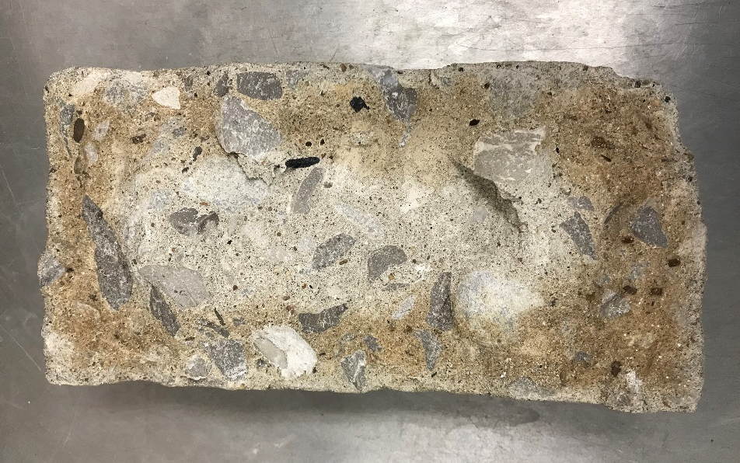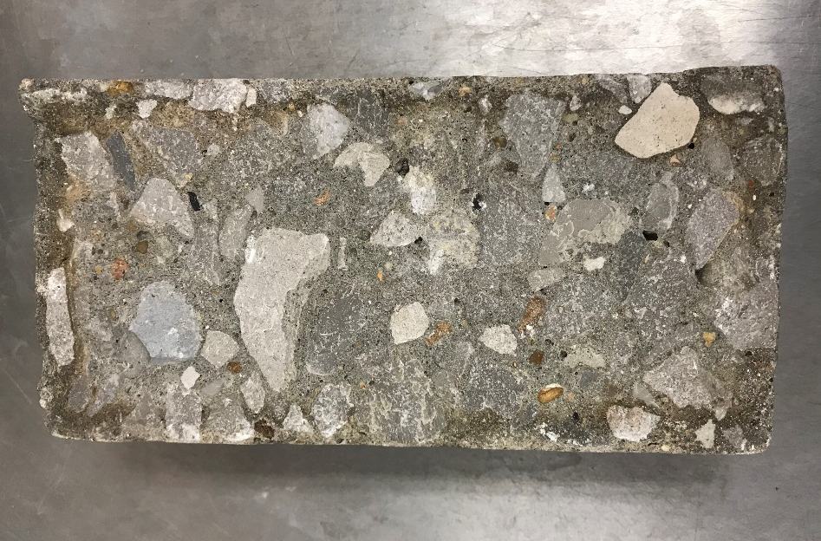

Figure 2: Magnesium Chloride Salt Solution Penetration Depth in 4-by-8-inch Cylinders (a) 3500-psi (b) CRED Level 1

The percent losses calculated in Tables 11, 12, and 13 were determined by subtracting the 196-day result from the 28-day result and dividing the difference by the 28-day result. The answer was expressed as a percent loss. The percent loss was reported to the nearest positive number (increases in engineering properties were ignored). Percent gains in Table 14 were calculated in a similar manner.

Table 11: Mean Compressive Strength of 4-by-8-inch Cylinders (psi)

 | Commercial 3500-psi | Commercial 3500-psi with Sealer | Commercial 4000-psi | Commercial ACI 332 | CRED Level 1 | CRED Level 2
28-days | 5200 | 5360 | 6070 | 6610 | 8770 | 10330
196-days | 3160 | 5070 | 4060 | 5590 | 10200 | 11430
% Loss | 39.2 | 5.4 | 33.1 | 15.4 | 0 | 0

Table 12: Mean Split Tensile Strength of 4-by-8-inch Cylinders (psi)

 | Commercial 3500-psi | Commercial 3500-psi with Sealer | Commercial 4000-psi | Commercial ACI 332 | CRED Level 1 | CRED Level 2
28-days | 440 | 445 | 520 | 530 | 565 | 770
196-days | 280 | 320 | 290 | 325 | 615 | 575
% Loss | 36.4 | 28.1 | 44.2 | 38.7 | 0 | 25.3

Table 13: Mean Static Modulus of Elasticity of 4-by-8-inch Cylinders (psi)

 | Commercial 3500-psi | Commercial 3500-psi with Sealer | Commercial 4000-psi | Commercial ACI 332 | CRED Level 1 | CRED Level 2
28-days | 3950000 | 4050000 | 4150000 | 4300000 | 4650000 | 5550000
196-days | 2500000 | 2650000 | 2650000 | 2500000 | 4900000 | 5300000
% Loss | 36.7 | 34.6 | 36.1 | 41.9 | 0 | 4.5

Table 14: Absorption after Boiling of 3-by-6-inch Cylinders (%)

 | Commercial 3500-psi | Commercial 3500-psi with Sealer | Commercial 4000-psi | Commercial ACI 332 | CRED Level 1 | CRED Level 2
28-days | 5.28 | 2.27 | 5.25 | 4.96 | 4.28 | 3.80
196-days | 6.65 | 6.03* | 6.65 | 6.20 | 4.71 | 4.32
% Gain | 25.9 | * | 26.7 | 25.0 | 10.0 | 13.7
* - the iterative process of boiling / drying for removing MgCl salt proved inappropriate for penetrating sealers (sealer melted). Penetrating sealers were not designed for such high temperatures. Therefore, the authors ignored the 196-day absorption after boiling results of the 3500-psi sealed mixture.
Table 15 shows rankings (1 to 6, 1 best) for each evaluation used in the TCA study. The mean ranking is also included to provide a relative comparison of mixture performance.

Table 15: Summary of Preliminary Analysis by Performance Ranking to Data

 | Commercial 3500-psi | Commercial 3500-psi with Sealer | Commercial 4000-psi | Commercial ACI 332 | CRED Level 1 | CRED Level 2
Minimum Salt Intrusion Depth | 6 | 1 | 4 Tie | 4 Tie | 2 | 3
Minimum Weight Gain | 6 | 1 | 5 | 4 | 3 | 2
Minimum Compressive Strength Loss | 6 | 3 | 5 | 4 | 1 | 2
Minimum Split Tensile Strength Loss | 4 | 3 | 6 | 5 | 1 | 2
Minimum Static Modulus of Elasticity Loss | 5 | 3 | 4 | 6 | 1 | 2
Absorption after Boiling Gain | 4 | * | 5 | 3 | 1 | 2
Mean Ranking | 5.2 | 2.2 | 4.8 | 4.3 | 1.5 | 2.2

Preliminary Conclusions

Based on the limited data available (only one commercially-available magnesium chloride deicing salt and five different concrete mixtures) the following conclusions can be drawn:

- Using a low permeability concrete mixture or a concrete mixture treated with a penetrating sealer greatly reduces both the rate and amount of magnesium chloride deicer salt intrusion into the concrete.

- Using a low permeability concrete mixture or a concrete mixture treated with a penetrating sealer greatly reduces the concrete compressive strength loss due to magnesium chloride deicer salt intrusion.

- Using a low permeability concrete mixture or a concrete mixture treated with a penetrating sealer reduces the concrete split tensile strength loss due to magnesium chloride deicer salt intrusion.

- Using a low permeability concrete mixture greatly reduces the concrete static modulus of elasticity (stiffness) loss due to magnesium chloride deicer salt intrusion.

- Using a low permeability concrete mixture greatly reduces the increase in hardened concrete absorption due to magnesium chloride deicer salt intrusion.

- Preliminary indications are that using a low permeability concrete or a concrete mixture treated with a penetrating sealer should substantially increase the service life (greatly delay deterioration) of commercial or residential concrete exposed to commercial deicing salts containing magnesium chloride.

What’s next for the TCA Magnesium Chloride Durability Study?

The TCA study continues and final results are expected by spring 2020.

Disclaimer

The opinions expressed herein are those of the authors and not necessarily the opinions of the Tennessee Concrete Association (TCA).

References

- “Snow and Ice.” Snow & Ice - FHWA Road Weather Management, FHWA, Feb. 2017, https://ops.fhwa.dot.gov/weather/weather_events/snow_ice.htm.

- “Winter Maintenance Virtual Clearinghouse: Technical Briefs.” FHWA Road Weather Management - Winter Maintenance Virtual Clearinghouse: Technical Briefs, FHWA, Feb. 2017, https://ops.fhwa.dot.gov/weather/resources/publications/tech_briefs/tech_briefs.htm.

- Sumsion, Eric S., and W. Spencer Guthrie. PHYSICAL AND CHEMICAL EFFECTS OF DEICERS ON CONCRETE PAVEMENT: LITERATURE REVIEW. 2013, www.udot.utah.gov/go/research.

- Hilding, Tina. “Researchers Uncover Hidden Deicer Risks Affecting Bridge Health.” WSU Insider: Washington State University, Washington State University, 5 Apr. 2019, https://news.wsu.edu/2019/04/04/researchers-uncover-hidden-deicer-risks-affecting-bridge-health/.

- Darwin, David, et al. “EFFECTS OF DEICERS ON CONCRETE DETERIORATION.” 2007.

- Riding, Kyle A., et al. “Performance-Based Specifications for Concrete Exposed to Chlorides Alternative Approaches for Durability.” www.concreteinternational.com%7CCi%7CJULY201841.

- “Permeability of Concrete.” American Concrete Institute, ACI, https://www.concrete.org/topicsinconcrete/topicdetail/permeability of concrete.

- “Supplementary Cementing Materials.” Supplementary Cementing Materials, Portland Cement Association, https://www.cement.org/cement-concrete-applications/concrete-materials/supplementary-cementing-materials.

- Mindess, Sidney, et al. Concrete. 2nd ed., Prentice Hall, 2003, pp. 477-513.

- Ramachandran, V. S., et al. “Superplasticizers: Properties and Applications in Concrete.” Minister of Public Works and Government Services, Canada, 1998, pp. 38.

- ACI Committee 201. Guide to Durable Concrete. ACI 201.2R-08. American Concrete Institute, 2013. Print.

- “Fly Ash Decreases the Permeability of Concrete.” Boral Resources, Technical Bulletin 6, 2018, https://flyash.com/wp-content/uploads/assets/Boral-TB6-Fly-Ash-Decreases-Permability.pdf.

- “User Guidelines for Waste and Byproduct Materials in Pavement Construction.” U.S. Department of Transportation/Federal Highway Administration, FHWA, Aug. 2016, https://www.fhwa.dot.gov/publications/research/infrastructure/structures/97148/bfs3.cfm.

- ASTM Standard C39/C39M, 2018, “Standard Test Method for Compressive Strength of Cylindrical Concrete Specimens.” ASTM International, West Conshohocken, PA, 2018, DOI: 10.1520/C0039_C0039M-18

- ASTM Standard C496/C496M, 2017, “Standard Test Method for Splitting Tensile Strength of Cylindrical Concrete Specimens.” ASTM International, West Conshohocken, PA, 2017, DOI: 10.1520/C0496M-17.

- ASTM Standard C469, 2014, “Standard Test Method for Static Modulus of Elasticity and Poisson’s Ratio of Concrete in Compression.” ASTM International, West Conshohocken, PA, 2014, DOI: 10.1520/C0469_C0469M-14, www.astm.org

- ASTM Standard C642, 2013, “Standard Test Method for Density, Absorption, and Voids in Hardened Concrete.” ASTM International, West Conshohocken, PA, 2013, DOI: 10.1520/C0642-13, www.astm.org

- AASHTO T 358-17. “Standard Method of Test for Surface Resistivity Indication of Concrete’s Ability to Resist Chloride Ion Penetration”. American Association of State Highway and Transportation Officials. Provisional Standards, 2017 edition, April 2017.

- ACI Committee 332. Residential Code Requirements for Structural Concrete. ACI 332-14. American Concrete Institute, 2014. Print.

- ACI Committee 332. Code Requirements for Residential Concrete. ACI 332-08. American Concrete Institute, 2008. Web.
Acknowledgements

The authors appreciate the financial and technical support provided by the Tennessee Concrete Association.
The authors would like to thank Denny Lind of BASF for extensive donations of chemical admixtures to the project. Also, the authors would like to thank Martin Medley for donations of materials used in this project.
In addition, the authors would like to thank Mark Davis and Perry Melton for their patience and skill in fabrication, maintenance, and repair of the equipment.
Further, we appreciate the financial support of the TTU Department of Civil and Environmental Engineering.
Finally, the authors appreciate the administrative, financial and information technology support provided by the TTU Center for Energy Systems Research, particularly Dr. Satish Mahajan, Robert Craven, Etter Staggs, and Anysa Milum.
Author Information

L. K. Crouch, Ph.D., P.E. is a professor of Civil Engineering at Tennessee Technological University.

Samuel Mathews, E.I. is a civil engineering master’s student at Tennessee Technological University.

Daniel Badoe, Ph.D. is a professor of Civil Engineering at Tennessee Technological University.

Alan Sparkman, CAE, LEED AP, CCPf, is executive director of the Tennessee Concrete Association

